ONLINE TEST
Candidate Orientation Guide

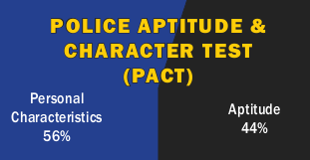

for
Entry-Level Police Officer

Reading Ability, Mathematical Reasoning, Writing Ability,
Reasoning Ability and Human Relations

Provided by Fire & Police Selection, Inc. (FPSI)—2020

This download is intended for a single use guide and has a 2020 Copyright License.
Reproducing, communicating or making photocopies of any of the material
contained herein is against FPSI policy and federal Copyright laws.

