Vancouver Fire Rescue Services

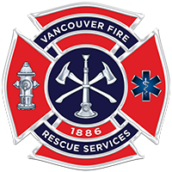

NFST/CFT
Candidate Orientation Guide

Reading Ability, Mathematical Reasoning, Map Reading,
Writing Ability, Human Relations, Reasoning Skills, and
IFSTA Essentials of Fire Fighting, 6th Edition items.

National Fire Select Test™
Provided by Fire & Police Selection, Inc. (FPSI)—2019

This download is intended for a single use guide and has a 2009 Copyright License.
Reproducing, communicating or making photocopies of any of the material
contained herein is against FPSI policy and federal Copyright laws.

